

RIPON STUDENT EMPLOYMENT

**Work Study Handbook for Students and Supervisors**

## A guide to the

*Federal and College Work Study Programs*

Contents

Quick Reference Charts

I. Introduction Information 1

A. Student Handbook Statement 1

B. Types of Student Employment 1

C. Ripon College Work Study 1

II. Policies and Procedures for Students 2

A. General Guidelines 2

B. Securing a Job on Campus 2

C. Employee Rights and Responsibilities 3

D. On-line Timecards (detailed instructions Appendix B) 4

E. Pay Rates 5

F. Discipline/Termination 5

G. Breaks and Holidays 5

III. Policies and Procedures for Supervisors 6

A. Requesting a Work Study Student Employee 6

B. Interviewing Student Employees 6

C. Hiring a Work Study Student Employee 7

D. Orienting Your Student Employee 7

E. Work Study Supervisor Guidelines for Timesheets 7

*Detailed Instructions on Approving and Submitting Timecards (Appendix C)* 21

F. Discipline/Terminations 8

Appendix A: Forms needed for Payroll once job is secured 9

Appendix B: Paycom Self-Onboarding Process 9

Appendix C: Instructions for Students completing On-Line Timecard 17

Appendix D: Instructions for Supervisors completing On-Line Timecard 21

Appendix E: List of Codes and Wages for Supervisor Reference 26

Appendix F: Job Description form needed for every Student Worker Job on Campus 28

# Introduction Information

### Student Handbook Statement

These guidelines, policies, and procedures have been developed to meet the needs of student workers and their supervisors. Students entering the work study program are required to uphold all policies and procedures outlined in this manual. If inappropriate behavior is demonstrated in the work study program, the student will be accountable by this handbook. Any questions regarding this handbook should be addressed to Linda Kinziger, Director of Financial Aid or Paula Stettbacher, Director of Human Resources or Jennifer Franz, Payroll Assistant.

### Types of Student Employment

#### Federal Work Study (FWS)

The Federal Work Study Program is a federally funded work program which provides the opportunity of employment to eligible students with financial need, helping them to earn money to help pay education expenses. A FWS award is financial aid, and as with other types of financial aid, student eligibility is determined by the Financial Aid Office.

#### College Work Study (CWS)

College Work Study is funded by Ripon College and provides the opportunity of employment to all students, helping them to earn money to help pay education expenses. Student eligibility for College Work Study also initiates in the Financial Aid Office.

### Ripon College Work Study

Between the Federal and College Work Study Programs, Ripon College employs 350 students in 570 different jobs on campus, paying $600,000 in wages during the academic year.

# Policies and Procedures for Students

### General Guidelines

The Work Study program is designed to help students meet educational expenses through meaningful employment. Jobs vary throughout the college and range from assisting in various departments to working in the library or food service, tutoring or being a lifeguard at the pool. Your work schedule is based upon your class schedule and you are never expected to work when you have a class.

### Securing a Job on Campus

* 1. Available on campus jobs for students are posted in Handshake.
     + Logging into Handshake will help you find available student jobs on campus
       1. Under “Quick Links” in the portal select Handshake (left navigation bar)
       2. Login to Handshake with your MyRipon NetID
       3. You can update your profile and add documents
       4. To search for an on campus job, select the “jobs” tab, then click “on campus”
  2. After securing a job(s) on campus, students must complete the *Student Appointment* *Form* (Appendix A) to initiate the Paycom Self-Onboarding process. This form should be delivered to the Financial Aid Office when complete.
     + ***Student Appointment*** form - fill out the top section – *Student Information*
       1. The check boxes will help you determine which additional documents are needed
       2. If you have never been paid for work performed on campus, you will need to complete the onboarding process through Paycom.
     + ***Employment Eligibility Verification (I-9), Direct Deposit Form, W4 Tax Withholding*** form - **only needed** if you have never been on Ripon College's payroll. Complete in Paycom Onboarding
  3. After the *Student Appointment* *Form* has been completed by the supervisor and handed into the Financial Aid Office, the student will receive an email from Paycom to begin their Onboarding Process. (Appendix B)

### Employee Rights and Responsibilities

###### Rights:

* 1. Information regarding their award amount, rate of pay, average number of hours per week, and general Work Study (WS) procedures.
  2. Instructions regarding procedures to be followed if the student cannot report for a scheduled work period.
  3. A clearly defined work schedule, which accommodates their course schedule and academic requirements.
  4. Adequate training to perform assigned tasks.
  5. A safe, clean, and professional working environment.
  6. Supervision and direction from Ripon College faculty or staff.
  7. Instructions for recording hours worked, as well as information regarding the College’s payroll procedures and payroll calendar.

###### Responsibilities:

1. For security and confidentiality of records and/or data files, the College has a policy of administering and maintaining student records in compliance with the Family Educational Rights and Privacy Act of 1974, as amended. As an employee, each student holds a position of trust relative to maintaining the security and confidentiality of these records and must recognize the responsibility entrusted to them.
2. Student employees are not allowed to study, nor do homework while they are working. If your supervisor approves you doing homework, it must be while serving a need of the work site at the same time (i.e. answering the phone, greeting visitors, etc.)
3. Communicate with supervisors regarding schedule
4. Notify supervisor immediately if unable to attend work
5. Understand the expectations from individual supervisor
6. Notify the Financial Aid Office or Human Resources Office in the event of an inappropriate work environment
7. Maintain professionalism and accuracy in all transactions with the public or campus community
8. NOT WORK OVER 20 hours/week between all of the jobs held on campus.

### On-line Timecards (detailed instructions Appendix C)

* 1. Students are paid once per month (Appendix D). A week runs from Sunday through Saturday. On the Monday after the last day of the pay period, students must make sure all of the hours worked are accurately recorded on their timecard
  2. If more than one job/position is held by a student, the student must ensure the correct timecard is used when recording hours worked.
  3. Pull up your timecard(s) in Paycom
  4. Hitting the *Finalize* button is equivalent to signing and submitting a paper timesheet. A timecard is a legal document. Timecards **must** accurately reflect all hours worked. Misrepresentation of hours worked or forgery is a violation of the law. Misrepresenting hours worked or forging a timecard may lead to immediate termination of employment. It is the responsibility of the student worker to submit their timecard, by hitting the Finalize button, to their supervisor for their signature. Timecards must be accurately completed and submitted by noon on Monday following the end of a pay period. Failure to submit timecards by the deadline may result in a delay in receiving payment for pay period.
  5. Your supervisor(s) can un-finalize your card if a change needs to be made but once they submit your card to payroll, it cannot be modified on-line. Changes can be communicated to HR via email ([set](mailto:franzj@ripon.edu) up HR email and list here) with both the supervisor and the student copied.
  6. Note that if your supervisor does not submit your Finalized timecard to payroll, you will not be paid until the next pay date. If you notice that your timecard has not been submitted, you should contact your supervisor. Any timesheet turned in after the deadline will be held for processing until the next pay period.

### Pay Rates

With only a few exceptions, pay rates across campus are all $7.25/hour. The few exceptions are as follows:

1. Student Support Services (SSS): Office Assistant, Peer Contact jobs are all paid at $7.75/hour

2. Food Service jobs at any Sage location are paid at $8.00-$9.00/hour

3. Lifeguards for Willmore Center Pool are paid $10.00/hour

4. Resident Assistants are paid $10.00/hour

1. **Discipline/Termination**

Student Employment is a part of the educational experience at Ripon College. Students are expected to meet

departmental expectations and follow policies. Issues with a Student Worker will be discussed with the student and

may go through the discipline process:

1. Verbal Warning and an improvement plan discussed

2. No change or another incident occurs; written warning with improvement and/or action plan discussed

3. No change or third incident occurs; second written warning or a termination at the discretion of the supervising department

**APPEALS:** A student may appeal an employment termination. For more information regarding this process, contact the Financial Aid Office.

### G. Breaks and Holidays

Students may work during semester breaks with the approval of their supervisor and pending available funding. During Fall, Winter, and Spring breaks, students can work up to 40 hours/week rather than the 20 hour limit. Students are not permitted to work on holidays that are observed by Ripon College.

# Policies and Procedures for Supervisors

### Requesting a Work Study Student Employee

### Departments and Offices indicate their need for work study students according to the budgeting process the Vice President of their area follows. The budget for work study students is completely separate from the budget for summer seasonal (student) workers/researchers.

* + After the budget has been confirmed, supervisors complete a Job Description Form (Appendix F) for each different position within their department/office. The form can be found on Google Docs and, once submitted, will be on file with the Financial Aid Office. Effective with the 2017-18 academic year, all job descriptions must be on file with the Financial Aid Office in order for a student worker to be entered into the payroll system.
  + Throughout the academic year, supervisors should communicate with Financial Aid to have open positions posted on Handshake.

### Interviewing Student Employees

* + Students will use the contact information in the Job Postings to arrange for an interview with a supervisor. It is beneficial for both you and your potential student employee to discuss the following during the interview:
    - Description of job duties.
    - Experience and skills needed to perform the job.
    - Personal conduct and dress expected.
    - Hours of operation and student's schedule of weekly hours.
    - Training and mentoring provided.
    - Expected date by which you will have made a hiring decision and start date.
    - Please note that the employment laws applying to interviewing regular employees also apply to the interviewing of student employees.
  + How to prepare for the interview:
    - Write interview questions that are criterion-based, behavior-based, job related, and non-discriminatory.
    - Decide whether you will do skills testing.
    - Set aside enough time to do an interview of substance that covers all requirements for the student employee to successfully perform the job.
    - Give each candidate a copy of the position description.
  + How to conduct the interview:
    - Make the candidate feel welcome and at ease.
    - Give the candidate an overview of how the interview will take place.
    - Wait for good answers and avoid talking too much.
    - Review employment dates and previous employment.
    - Determine interests, goals, strengths, and challenges.
    - Take notes during interview as needed to make an objective hiring decision.

### Hiring a Work Study Student Employee

1. Notify the student of your hiring decision within two to three days to ensure timeliness. Fill in the Supervisor section of the Student Worker Appointment form (Form - Appendix A; Reference - Appendix E) and return it to the student so he/she can take it to the Financial Aid Office. **The newly hired student cannot begin training or working until paperwork has been completed with Financial Aid.**
2. Student employees are paid by the hour.
   1. Holidays, snow days, and sick days are not to be counted as hours worked.
   2. Student employees are not paid for lunch or break periods.
   3. Overtime is not authorized for Work Study student employees.
   4. Regardless of the number of positions held, students may only work up to a total of 20 hours per week.

### Orienting Your Student Employee

Good personnel practices require that every employee be oriented to the organization of the work place and trained to perform necessary tasks. It benefits both you and the student to establish a formal training program and to keep the lines of communication open, clear, and constructive. Spend enough time discussing the following to prevent future confusion:

* + Performance standards.
  + Variations in work schedules for holidays and examination periods.
  + Student's responsibility for College facilities and equipment.
  + Safety and health practices.
  + Training in skills and procedures necessary to perform the job.
  + Confidentiality of records and files.
  + System access and security procedures.
  + Procedures for recording hours worked and completing timesheets.
  + Dress code in the workplace.
  + Telephone etiquette.
  + No homework policy (student employees are not allowed to study nor do homework on the job unless they are fulfilling a role for the work site at the same time, such as answering phones).

Provide answers to the following questions:

* Who is the student's supervisor?
* To whom should the student direct problems or questions?
* Who should be contacted in case of absence or change in work schedule?

### Work Study Supervisor Guidelines for Timesheets

### *Detailed Instructions on Approving and Submitting Timecards (Appendix C)*

##### When can a student employee start working?

Once the student has completed the interview process and you have signed the Appointment Form with the student, the student must submit the work-study packet to the Financial Aid Office prior to being set-up with an on-line timecard through Paycom. Students who never worked for the College before need to complete the Appointment Form, as well as complete the Onboarding Process in Paycom. Students previously employed by the College will only need to complete the Appointment Form and update their Payroll Deduction/Direct Deposit information in Paycom if needed. Once all paperwork has been received, the student can start work the first day of classes or after.

##### Who is responsible for keeping track of hours worked and remaining hours that a student may work within the semester?

The supervisor is solely responsible for ensuring that hours have been calculated accurately prior to submission of the on-line timesheet. Please remember that student employees can work up to 20 hours per week (Sunday - Saturday) between all of the jobs the student holds on campus. The supervisor should keep a running tally of the amount of hours worked by the student employee throughout the semester to ensure that the department/office budget is not exceeded.

##### Who must sign the student employee's timesheet?

Both the student employee and supervisor are required to 'sign' the on-line timesheet in order for it to be processed. See Appendix C for more detailed instructions on completing timesheets.

* Student's signature is signified by clicking the Finalize button.
  + If the student Finalizes his/her timecard before hours are complete, the Supervisor can un-Finalize the card by clicking on the student's underlined name which will open the timecard, clicking un-finalize, and saving the change.
* Supervisor's signature is signified by submitting the timecard to payroll. By clicking the Submit button, the supervisor is approving the days and hours that were worked by that student in the time period represented by the dates on that timecard.
  + Supervisors should correct any errors in hours recorded. This can be done by clicking on the pencil icon next to the student's name, making the corrections, and saving the document. The student will automatically be notified when corrections were made to his/her timecard. Once corrections have been made, the student can no longer alter that timecard.

##### When should timecards be submitted?

All timecards must be submitted to payroll by 4:00 p.m. on the Monday after the pay period has ended. It is the student’s responsibly to complete their timecard(s) by noon on Monday, so that Supervisors can submit them to payroll by 4:00 p.m. Late timecards will have to wait until the next payroll to be processed.

### Discipline/Termination

Student Employment is a part of the educational experience at Ripon College. Supervisors are expected to discuss departmental expectations and policies with their students.

**BEHAVIORS THAT SHOULD BE ADDRESSED**

(This list may be modified to suit department needs)

• Excessive tardiness or absenteeism

• Absent without legitimate excuse

• Carelessness or lack of attention

• Inappropriate workplace conduct

• Discourtesy or failure to work amicably with fellow employees

• Improper use of equipment (i.e.: computers)

• Violation of campus policies

**RECOMMENDED ACTION**

Supervisors should document discussions surrounding the following:

1. Verbal Warning and an improvement plan discussed

2. No change or another incident occurs; written warning with improvement and/or action plan discussed

3. No change or third incident occurs; second written warning or a termination at the discretion of the supervising department

**GROUNDS FOR ACTION/IMMEDIATE DISMISSAL**

Although following a corrective action plan is recommended, there are cases that may warrant immediate action or dismissal. Listed below are some examples:

• Breach of confidentiality

• Theft or gross negligence resulting in serious injury to property, person or public appearance

• Physical violence or obscene language/actions when dealing with the public or other staff

• Being under the influence of drugs or alcohol while on duty

• Falsification of timesheets

• Use of computers for inappropriate website searches/viewing

• Insubordination

• Excessive absenteeism or tardiness without prior notification

***All student employment termination requires notification to both the Financial Aid Office and Human Resources Office. Copies of all written documentation of discussions leading up to termination will be kept on file in the HR Office.***

**APPEALS:** A student may appeal an employment termination. For more information regarding this process, contact the Financial Aid Office.

Appendix A ***Student Appointment Form***

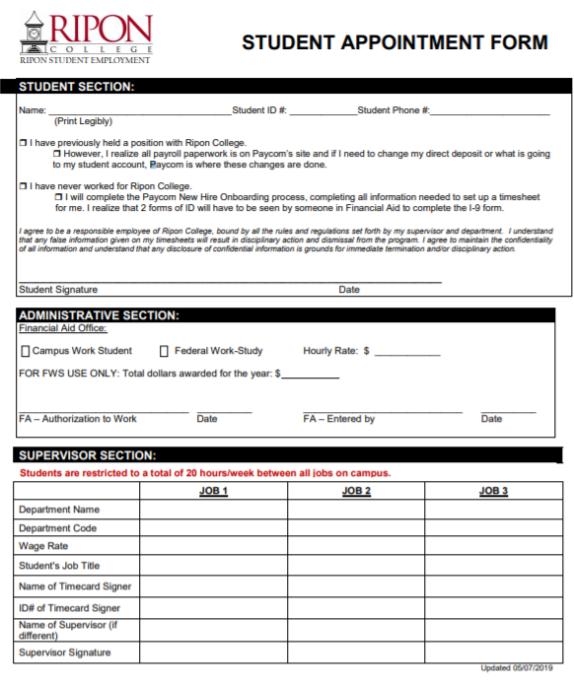

Appendix B ***Paycom Self-Onboarding Process***

Watch for emails from Paycom which come across with systemmessage as the sender. As a new hire you will receive Self On-Boarding information to login and verify some of your information. All steps in this onboarding process must be completed before you are added as an employee. The last step before being added as an employee is bringing your two forms of ID for the I-9 Document to Financial Aid at Smith Hall Room 106.

Forms of ID for the I-9 Document:

1. Unexpired Passport – can be shown to satisfy ID requirements, or

2. Driver License PLUS Birth Certificate, or

3. Driver License PLUS Social Security Card

Once you are an Active Employee, you will receive a new login and password for your Employee Self Service (ESS) account. Going forward this is the login credentials you will use to complete timecards and to make changes to any of your personal or tax information.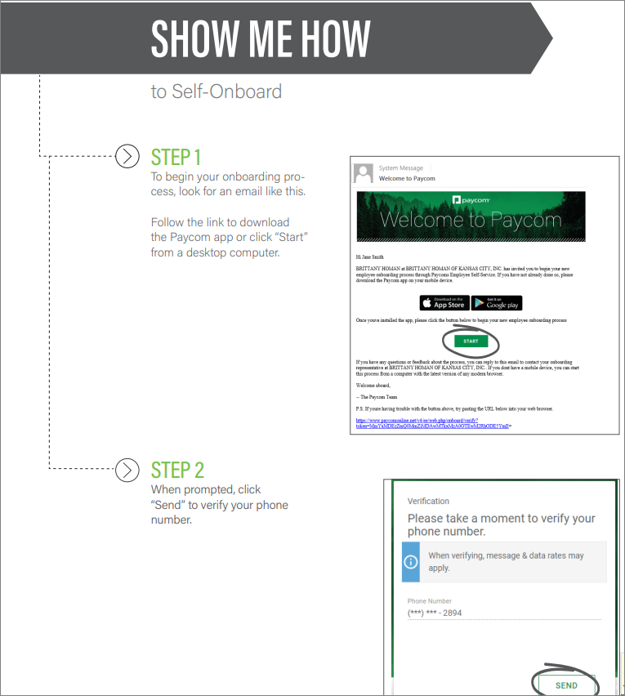

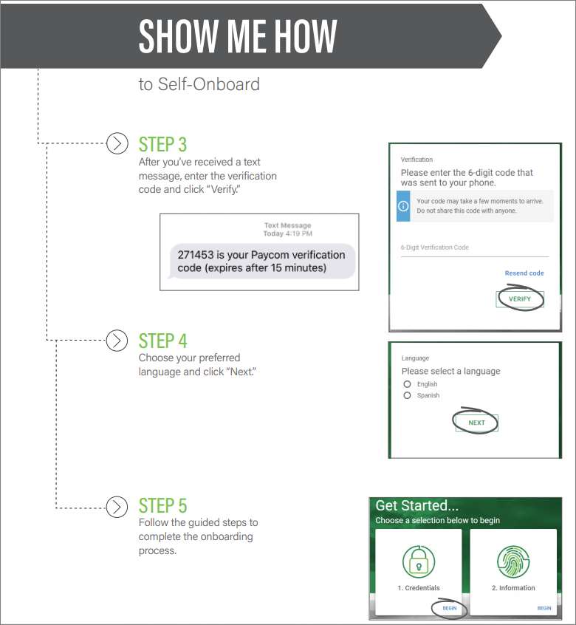

Appendix C ***Instructions for Students Completing Paycom Timecard***

**How do I enter hours on my timesheet:** When you go into your timesheet, you will click on +Add Punch, enter the date that you worked, the time you started and ended, and click on the drop down menu for Department to choose whichever Department you worked those hours for. If you only have one job on campus, you do not have to select the department.  When that is all completed, click the green Add Punch to transfer that information to the timesheet below. Your supervisor can re-open your timesheet if you need to make a change after approving your timesheet.

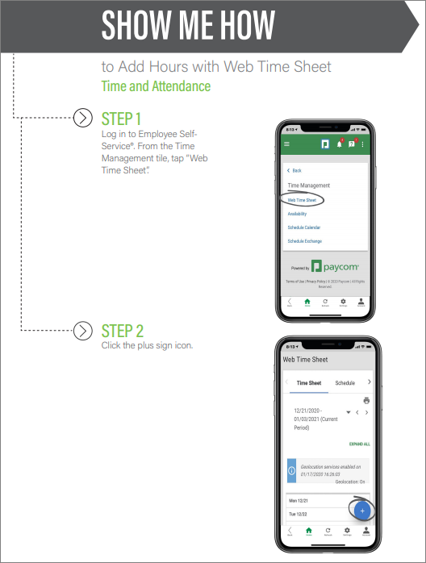

Using Your Cell Phone

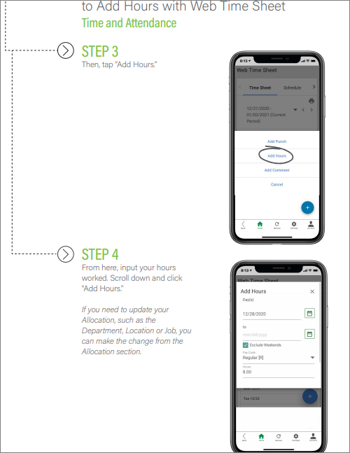

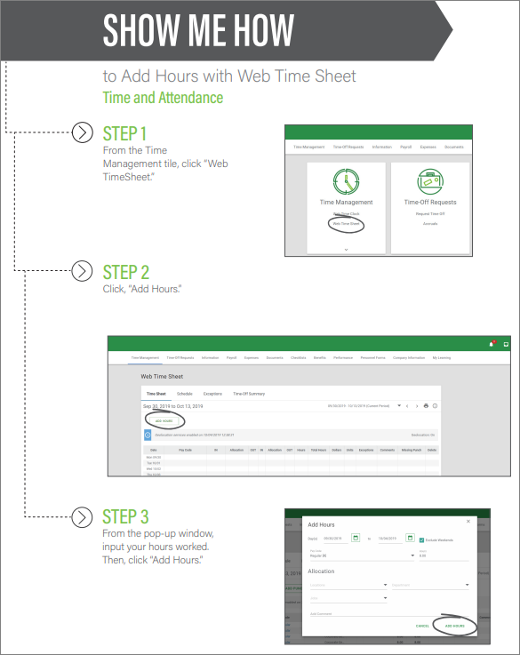

Using Computer to Login to Paycom

1. M**ake sure you are on the timecard for the correct time period**. If the correct time period is not showing, then arrow down move back in time.
2. You will only have one timecard for all the jobs you have on campus. The Primary Job you hold is listed under your name in Paycom. If entering punches for this job, you do not have to select a Department from the dropdown. If you are entering punches for a 2nd or 3rd job you have on campus, you MUST choose the appropriate Department from the dropdown.

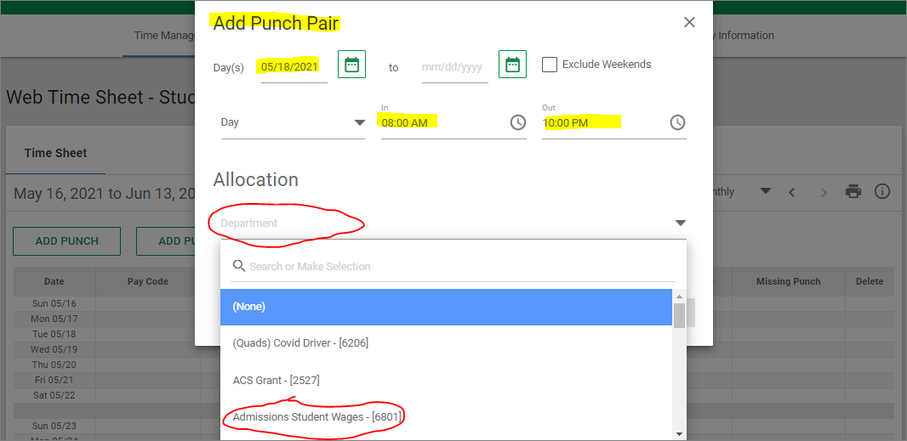

Before you approve your timecard, review it to make sure if In Punch has an Out Punch. If not, you will get a warning icon.

!

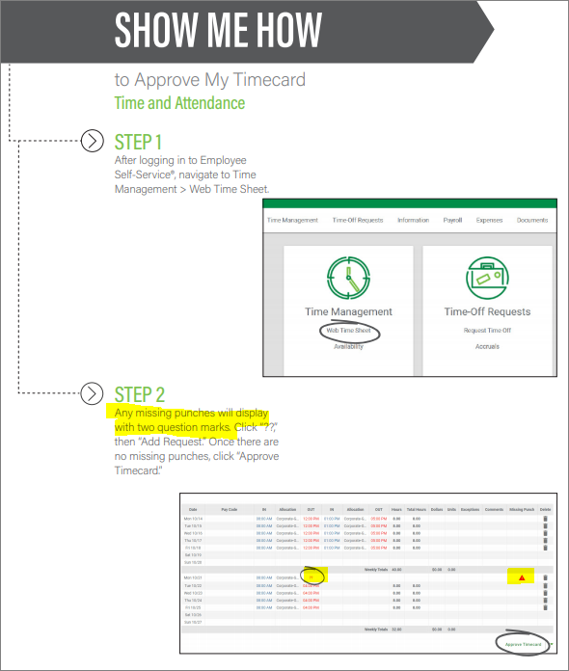

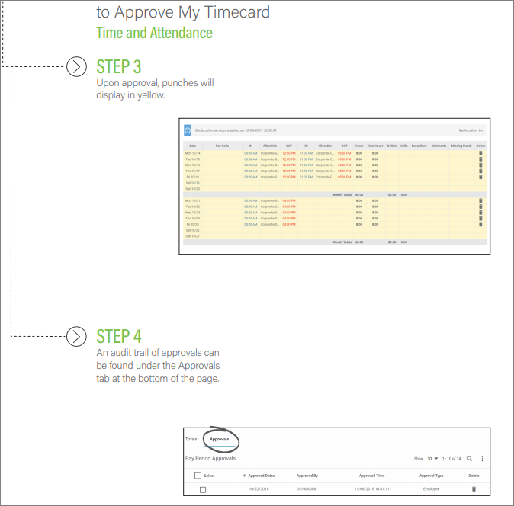

Appendix F ***Instructions for Supervisors Approving Student Timecards***

You will have two logins to Paycom: 1) a personal login where you can change your address, enroll in benefits, see your W2, look at check stubs, etc.; 2) a login for Supervisors to approve timesheets, respond to requests for time off, etc. **You should write down your login credentials for both until you get used to the process!**

Emails sent from Paycom will show up as 'systemmessage' in the sender column.

Although you will have two separate logins, once they are both set up, you will be able to login to either one and toggle between the two.

A:  To access your Supervisor screens:

Go to [paycom.com](http://paycom.com/)

Click on Login

Select Client

Enter Client Code: 0BQ07 (there are 2 zeros and no 'O's in this code)

Enter your Username: typically will be your first initial+last name (lower case, no spaces), but if that didn't create a 6-digit login, your combination of first-last-names could be different

Enter your temporary Password: ripon123

Once logged in, go to User Options/Change My Password to enter your own password.

B:  To access your Employee (personal)  screens:

Go to [paycom.com](http://paycom.com/)

Click on Login

Select Employee

Enter your username - if you didn't change your user name it is a 9-digit code that has zeros but no 'o's. I changed mine so I could remember what it is.

Enter your password - you would have been asked to change this the first time you logged in

Enter the last 4 digits of your Social Security number

C:  Toggle between Client and Employee

D:  Approving Timecards

Go to Time Management on the Client side/Timecard Search. Click on Multiple under filters and only select the type of employee (Student) you are approving for.  Click on Pay Period (not Date Range) and the current time period will come up. Then make sure to click Include Borrowed employees if you are approving Student Workers.

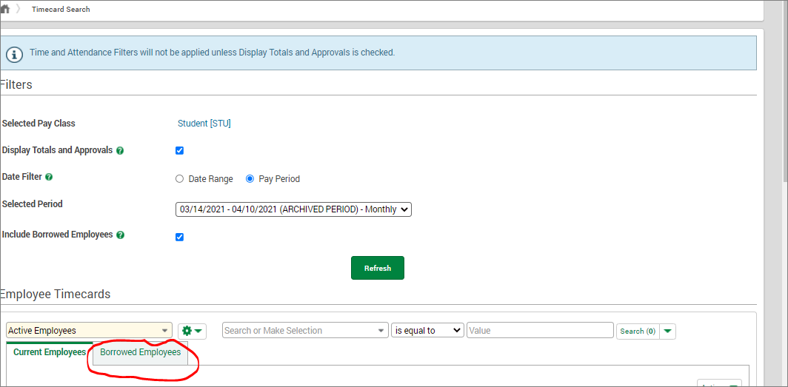

If your student has your department for their primary job, their timesheet will appear under Current Employees. If your student has your department as an additional job to what is set up as their primary, their timesheet will appear under Borrowed Employees BUT only if they have hours on their timesheet for your department.

When approving a student worker who has multiple jobs on campus, you should not approve the whole timecard. Otherwise, the other supervisors cannot approve the hours worked for their department. Each supervisor should review the timecard for hours marked for their department and if everything is good, leave a comment on the last day of the pay period. In the screenshot below, both Christina and Brenda approve the hours entered on this timecard for work done in their departments.

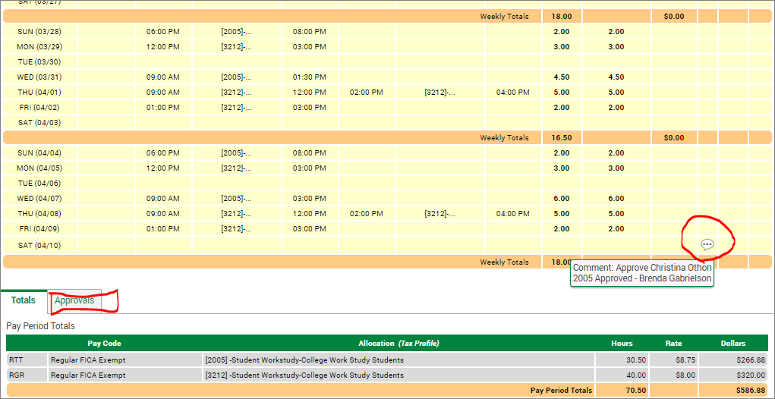

Appendix E ***Student Account Codes and Pay Rates***



APPENDIX F ***Student Worker Position Description Form***

# 

# 

# 